Step 1. Java jdk 11 installation from the following link and run it once completed.

[jdk-11.0.15.1_windows-x64_bin.exe](https://www.oracle.com/sa/java/technologies/javase/jdk11-archive-downloads.html#license-lightbox)

after installation go to command prompt and check java version

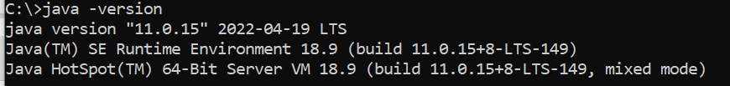

step 2. Maven configuration

download [apache-maven-3.8.6-bin.zip](https://dlcdn.apache.org/maven/maven-3/3.8.6/binaries/apache-maven-3.8.6-bin.zip) file from the link <https://maven.apache.org/download.cgi> to Document folder

extract [apache-maven-3.8.6-bin.zip](https://dlcdn.apache.org/maven/maven-3/3.8.6/binaries/apache-maven-3.8.6-bin.zip) in Document folder

step 3. Setting environment variable

go to edit environment variables setting

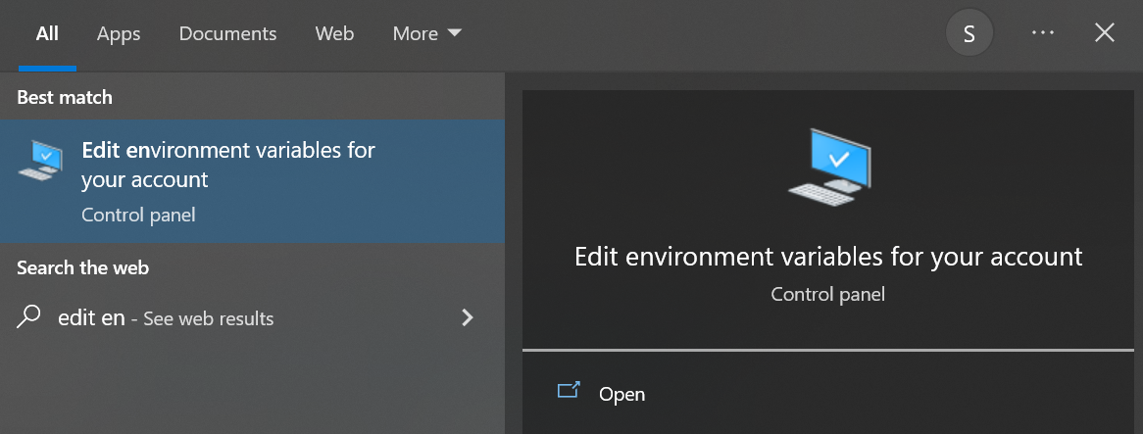

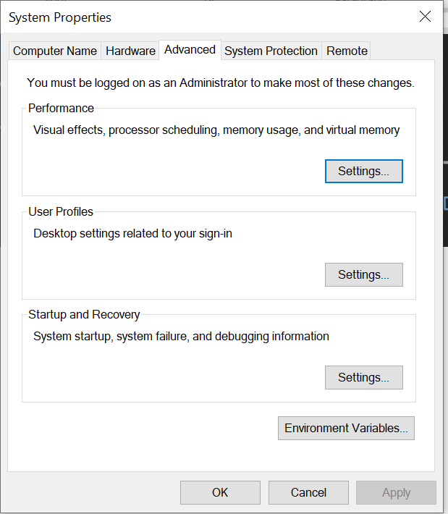

Go to environment Variable

Add variable JAVA_HOME

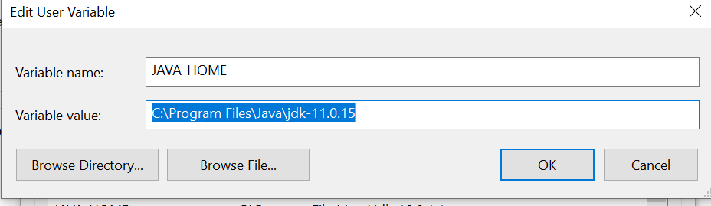

Add variable MAVEN_HOME

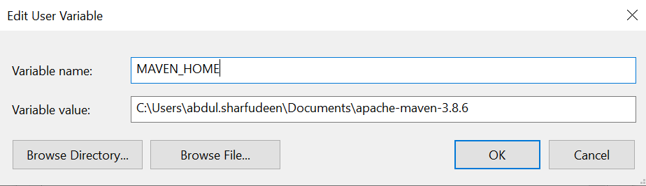

Go to command prompt and check the maven version

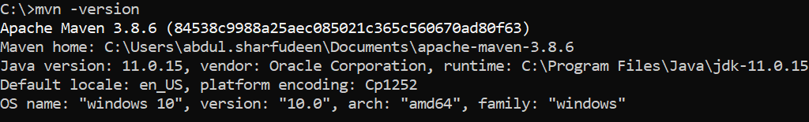

Now windows command is ready to run java project.

You can run java-based project in maven using IDEs.